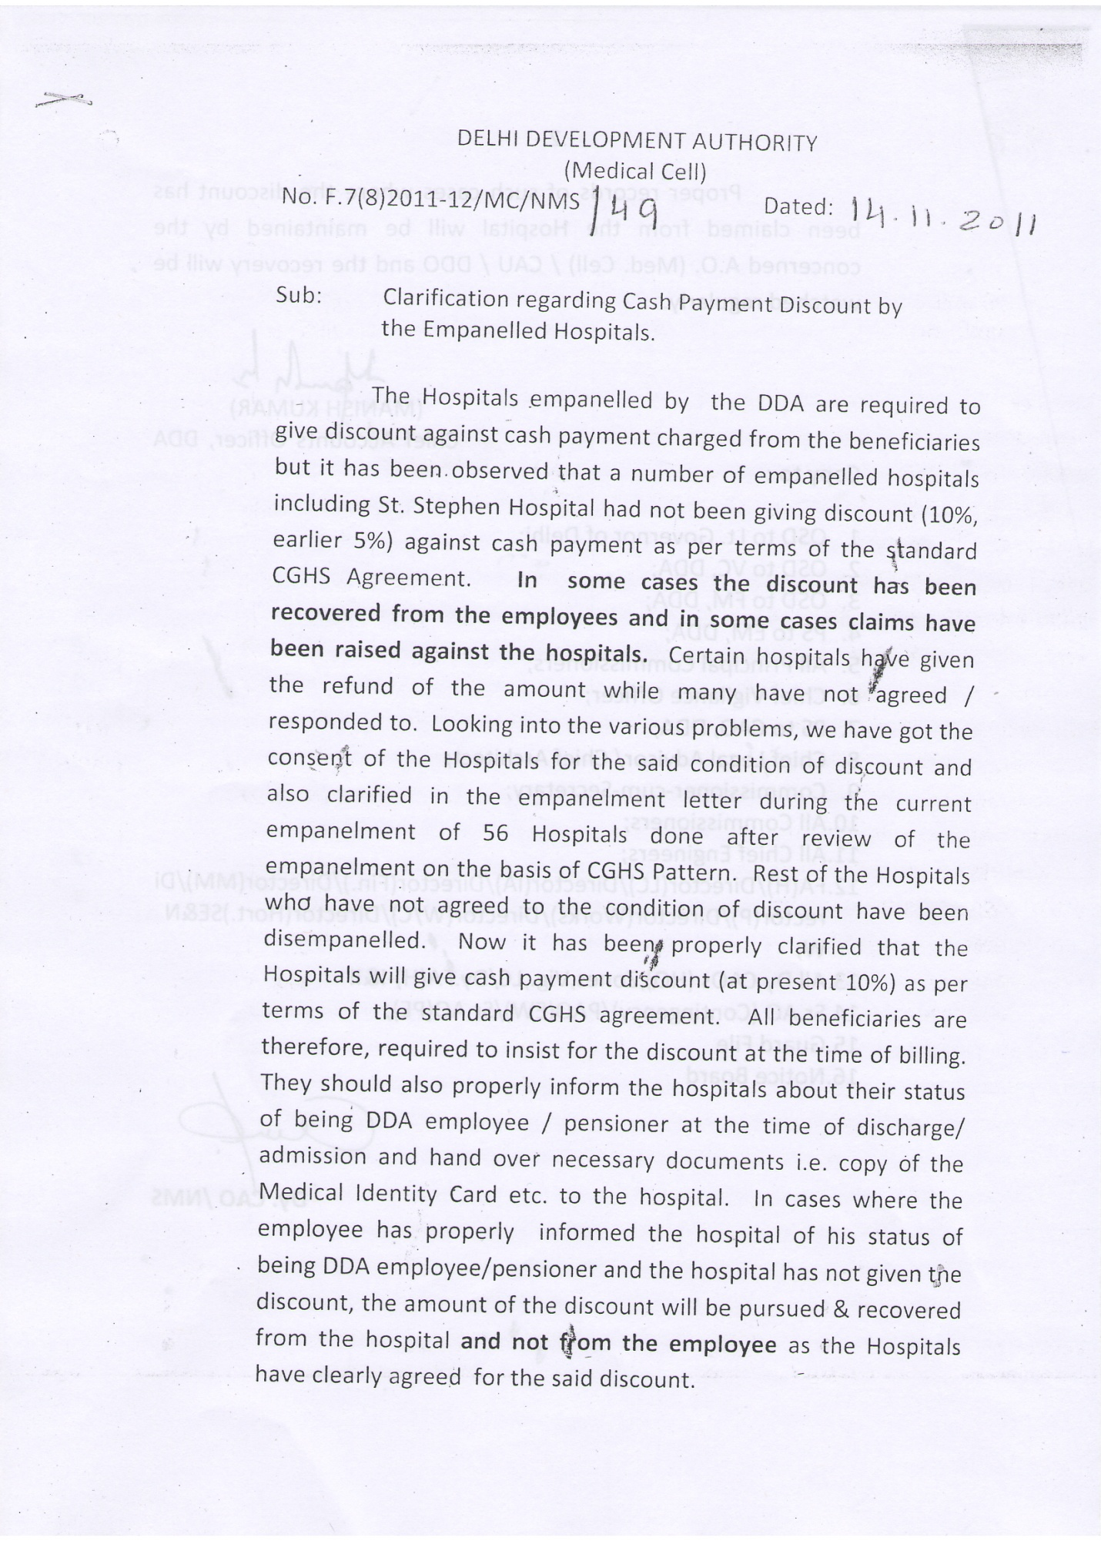
CLARIFICATION REGARDING CASH PAYMENT DISCOUNT BY THE
EMPANELLED HOSPITALS DATED 14.11.2011

